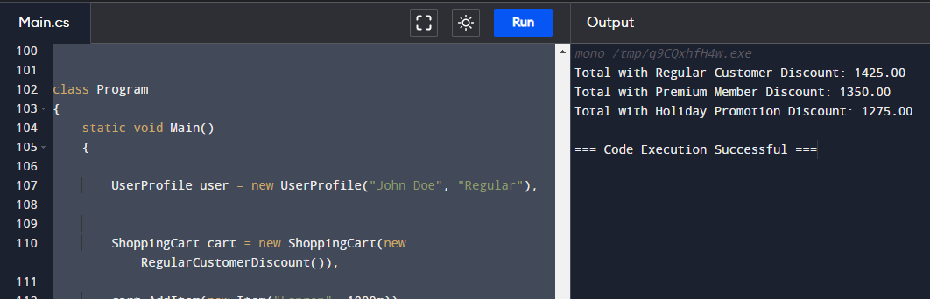

CODE:

using System;

using System.Collections.Generic;

public class Item

{

public string Name { get; set; }

public decimal Price { get; set; }

public Item(string name, decimal price)

{

Name = name;

Price = price;

}

}

public class UserProfile

{

public string UserName { get; set; }

public string LoyaltyLevel { get; set; }

public UserProfile(string userName, string loyaltyLevel)

{

UserName = userName;

LoyaltyLevel = loyaltyLevel;

}

}

public interface IDiscountStrategy

{

decimal ApplyDiscount(UserProfile user, decimal totalAmount);

}

public class RegularCustomerDiscount : IDiscountStrategy

{

public decimal ApplyDiscount(UserProfile user, decimal totalAmount)

{

return totalAmount \* 0.95m;

}

}

public class PremiumMemberDiscount : IDiscountStrategy

{

public decimal ApplyDiscount(UserProfile user, decimal totalAmount)

{

return totalAmount \* 0.90m;

}

}

public class HolidayPromotionDiscount : IDiscountStrategy

{

public decimal ApplyDiscount(UserProfile user, decimal totalAmount)

{

return totalAmount \* 0.85m;

}

}

public class ShoppingCart

{

private List<Item> items;

private IDiscountStrategy discountStrategy;

public ShoppingCart(IDiscountStrategy discountStrategy)

{

items = new List<Item>();

this.discountStrategy = discountStrategy;

}

public void AddItem(Item item)

{

items.Add(item);

}

public decimal CalculateTotal(UserProfile user)

{

decimal totalAmount = 0;

foreach (var item in items)

{

totalAmount += item.Price;

}

if (discountStrategy != null)

{

totalAmount = discountStrategy.ApplyDiscount(user, totalAmount);

}

return totalAmount;

}

public void SetDiscountStrategy(IDiscountStrategy newDiscountStrategy)

{

discountStrategy = newDiscountStrategy;

}

}

class Program

{

static void Main()

{

UserProfile user = new UserProfile("John Doe", "Regular");

ShoppingCart cart = new ShoppingCart(new RegularCustomerDiscount());

cart.AddItem(new Item("Laptop", 1000m));

cart.AddItem(new Item("Smartphone", 500m));

decimal total = cart.CalculateTotal(user);

Console.WriteLine("Total with Regular Customer Discount: " + total);

cart.SetDiscountStrategy(new PremiumMemberDiscount());

total = cart.CalculateTotal(user);

Console.WriteLine("Total with Premium Member Discount: " + total);

cart.SetDiscountStrategy(new HolidayPromotionDiscount());

total = cart.CalculateTotal(user);

Console.WriteLine("Total with Holiday Promotion Discount: " + total);

}

}